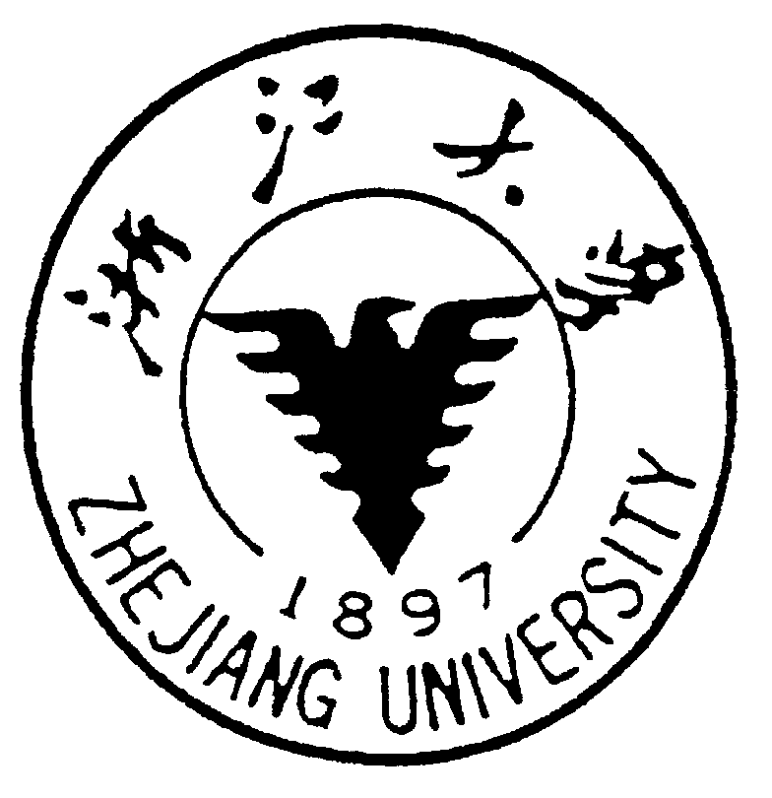 |   ZHEJIANG UNIVERSITY  中国·杭州 HANGZHOU CHINA | 邮政编码(POSTCODE): 310058  电话(TEL): 86-571-88981343  传真(FAX): 86-571-88981976  邮件(Email):0922C04@zju.edu.cn

June 16, 2008

Consulate General of Australia in Shanghai,
It is certified that Wang Haifeng, male, born on Dec. 7 1975, a professor of the College of Environment and Resource Science, Zhejiang University, has been approved to visit the University of Southern Queensland in Australia for 12 months beginning from Nov. 2008. Chinese Scholarship Council will provide financial support for him enough to cover the cost of living, food, lodging, medical insurance and a round trip ticket.
Wang Haifeng will still work in our University after he finishes visiting in Australia and returns to China.
Please afford convenience in case of need to his applying for the Visa to Australia.

Department of Human Resource
Zhejiang University
P. R. China

